How to Download Eclipse
MAKE SURE YOU DOWNLOAD JAVA FIRST!
Go to www.eclipse.org
Click on Download
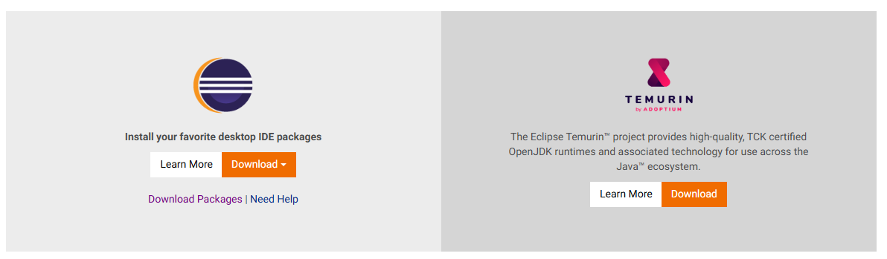
Click download packages
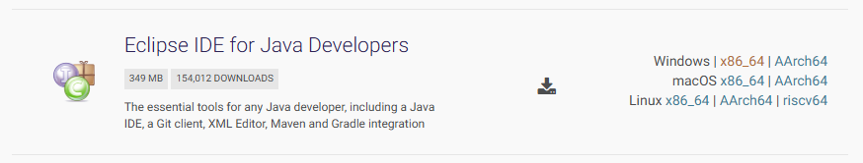
Go to IDE for Java Developers and choose the appropriate OS. For the school computers, it would be windows x86_64
Under Get Eclipse IDE, click on Download x86_64.
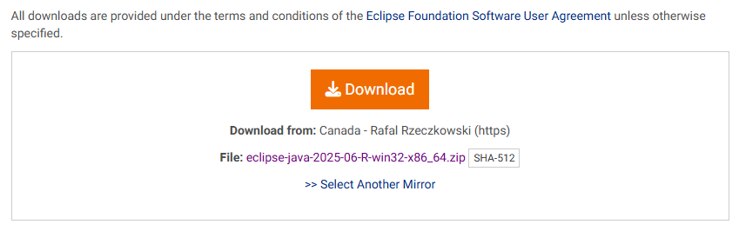
The download from: could be different than the image above, but you want to make sure the file is a .zip, if it is not select another mirror.
Once you find a .zip, click on it and it will start downloading. You can exit the website at this time.
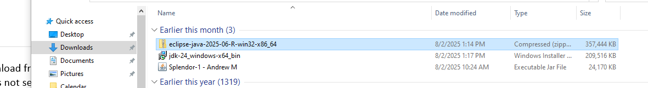
Right click on the eclipse zip and choose extract all
Select a destination, usually what they suggest is fine, and hit extract
Click on the eclipse folder that shows up
Click on the eclipse logo in the folder 
This will start eclipse up.
Eclipse will ask for the workspace directory. If you choose the C: drive, then you will only have this stuff saved to that specific computer. If you are using the schools computer, I highly recommend you choose to use your Katy ISD cloud under your student ID for the workspace. If you do that, you will have to always make sure you are connected to the cloud and you will be able to go to any computer you want.
When you are happy with the workspace, click launch
Finally, and most importantly, right click on the eclipse logo in the task bar and choose pin to taskbar
This doesn’t matter if your using your computer at home, however, if you use eclipse on the school computer, then you won’t be able to directly access the C: drive and therefor can’t go back to eclipse folder. However, if you pin to the taskbar, it will be there. If you ever lose the eclipse button, you will have to reuse the zip drive (which will be found in the downloads in the documents or if you saved it to your cloud drive)
Eclipse is now set up to be used!

